Week 3
Spring core and Maven

Exercise 1: Configuring a Basic Spring Application
Scenario:
Your company is developing a web application for managing a library. You need to use the Spring Framework to handle the backend operations.
Step 1: Set Up a Spring Maven Project
1.1 Create Maven Project
You can use IntelliJ IDEA or Eclipse:
- Project Name: LibraryManagement
- Group ID: com.library
- Artifact ID: LibraryManagement
1.2 Add Spring Core Dependencies in pom.xml
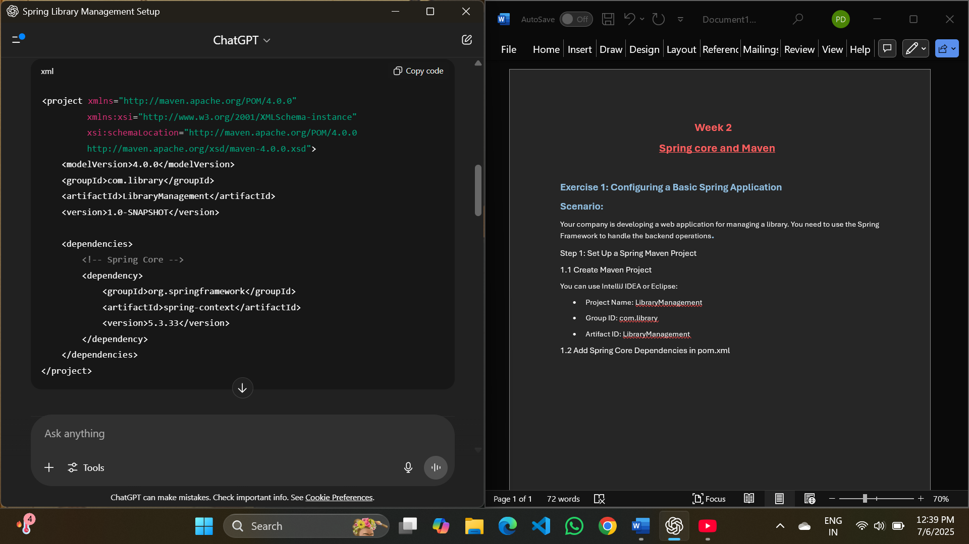

Step 2: Configure applicationContext.xml
2.1 Create File
- Path: src/main/resources/applicationContext.xml
2.2 Define Beans
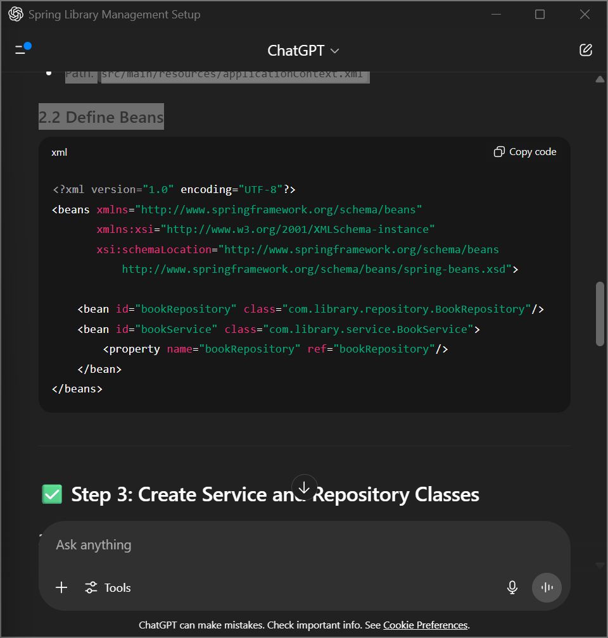

Step 3: Create Service and Repository Classes
3.1 BookRepository Class
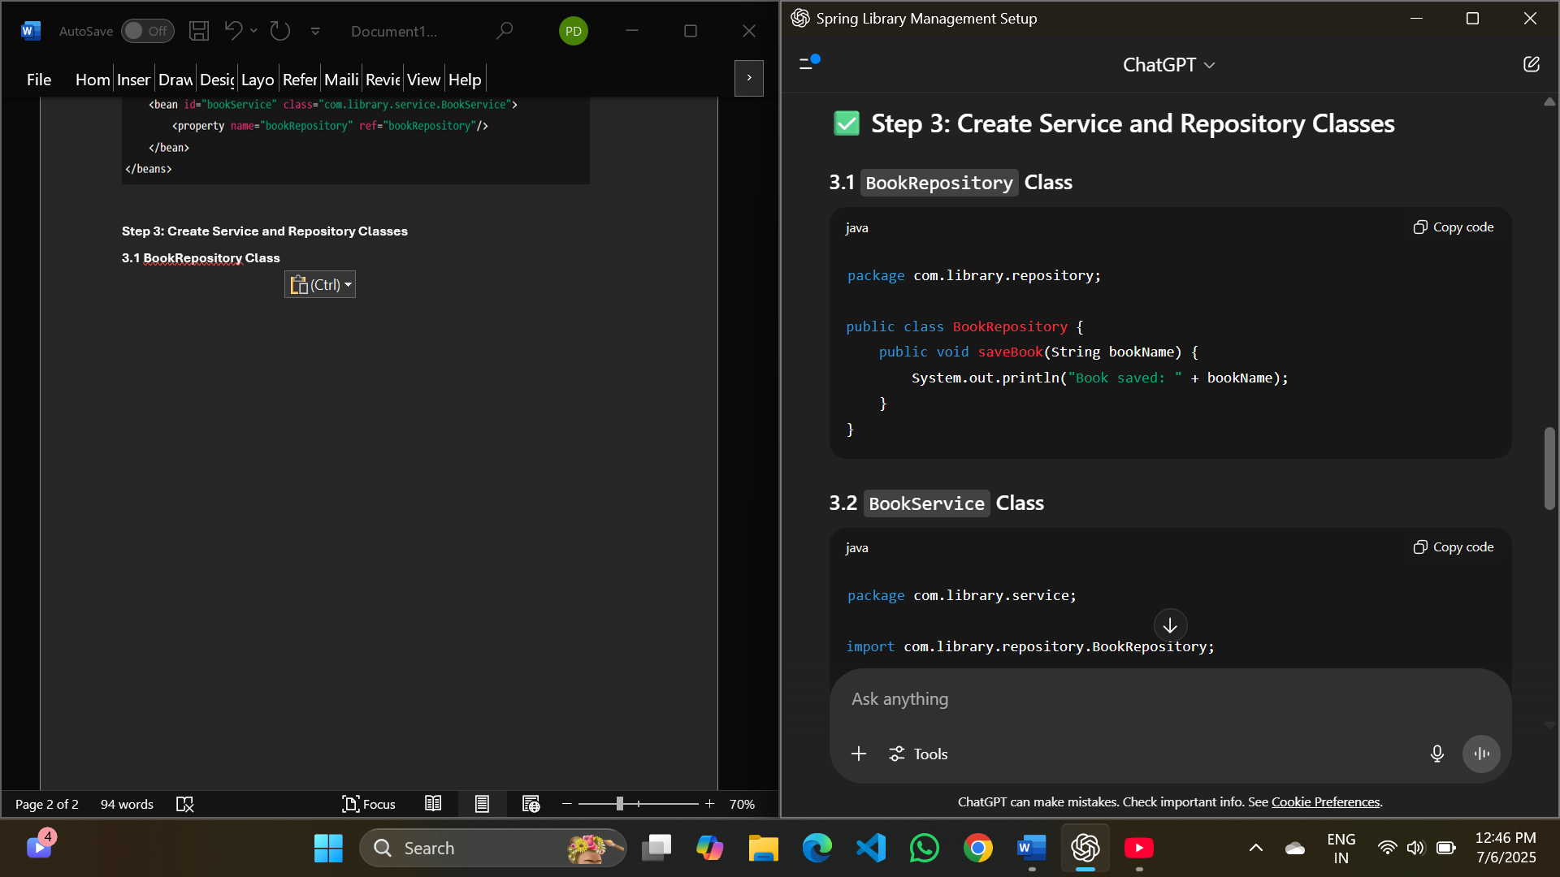
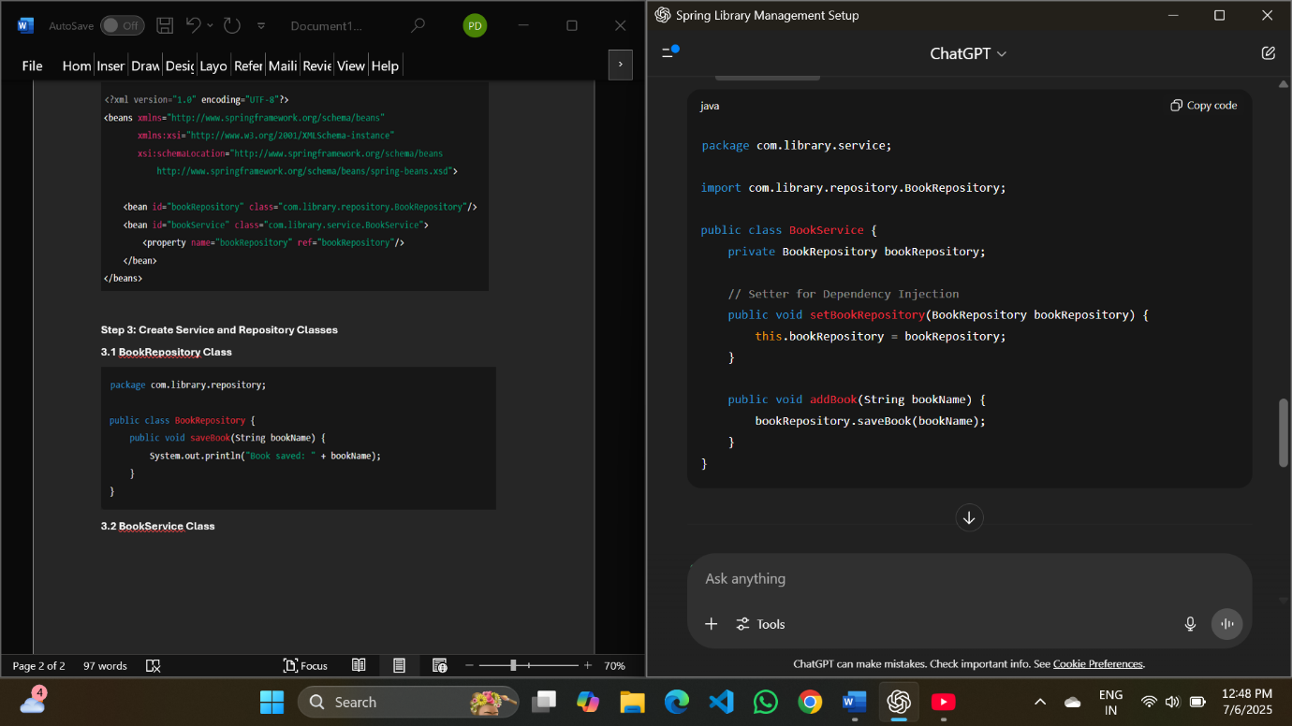
3.2 BookService Class
Step 4: Run the Application
4.1 MainApp Class
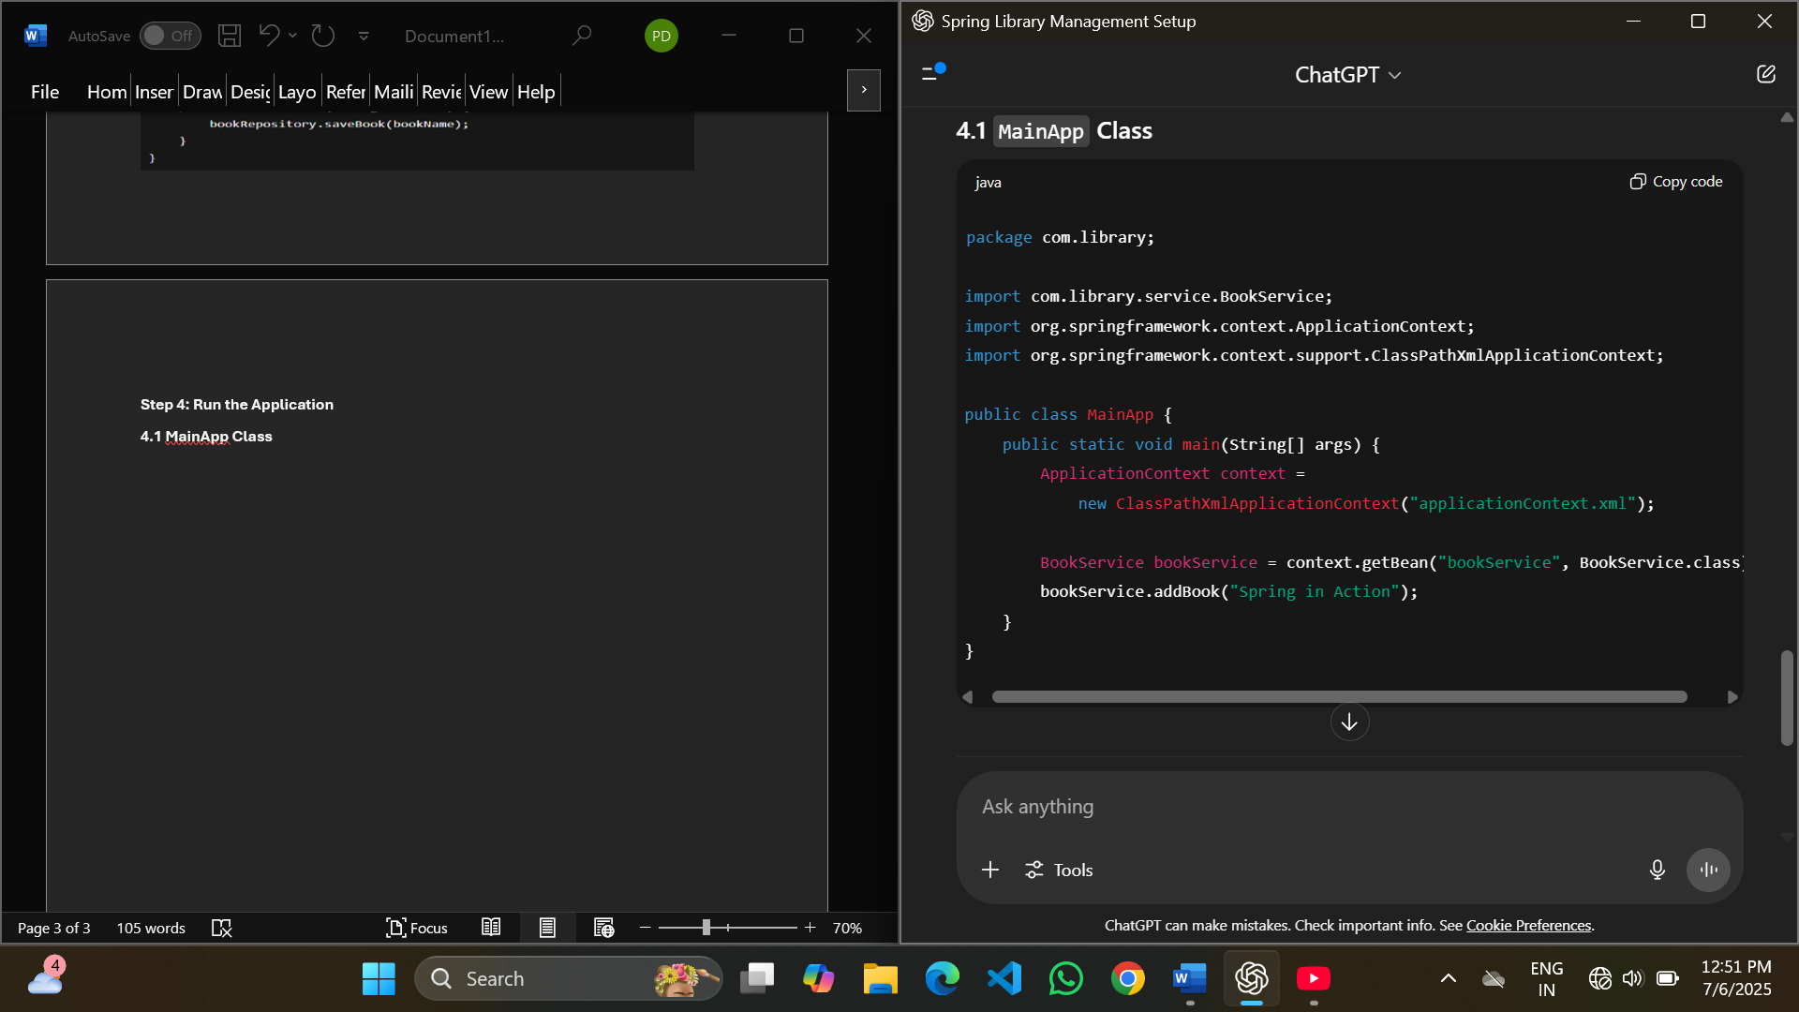

Output:
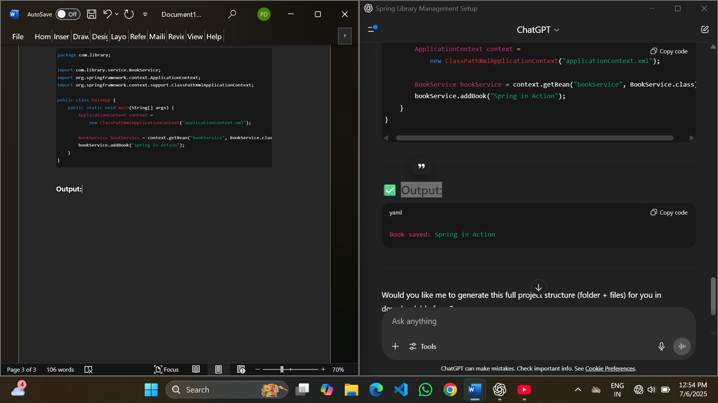

Exercise 2: Implementing Dependency Injection
Scenario:
In the library management application, you need to manage the dependencies between the BookService and BookRepository classes using Spring's IoC and DI.
Step 1: Modify the XML Configuration
Ensure that applicationContext.xml correctly wires the BookRepository into BookService.
Updated applicationContext.xml
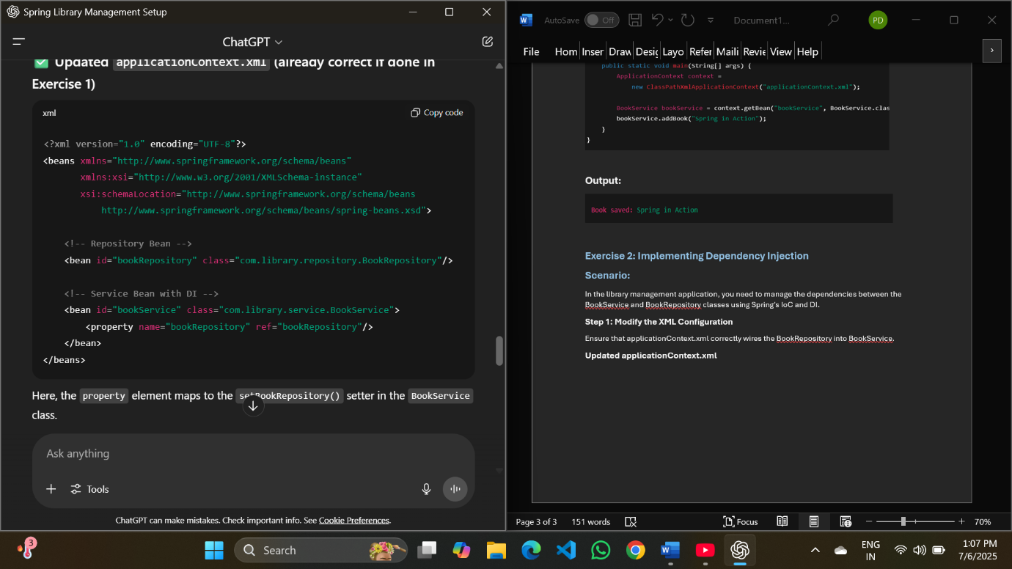
Step 2: Update the BookService Class
Ensure it includes a proper setter method for the repository.
BookService.java
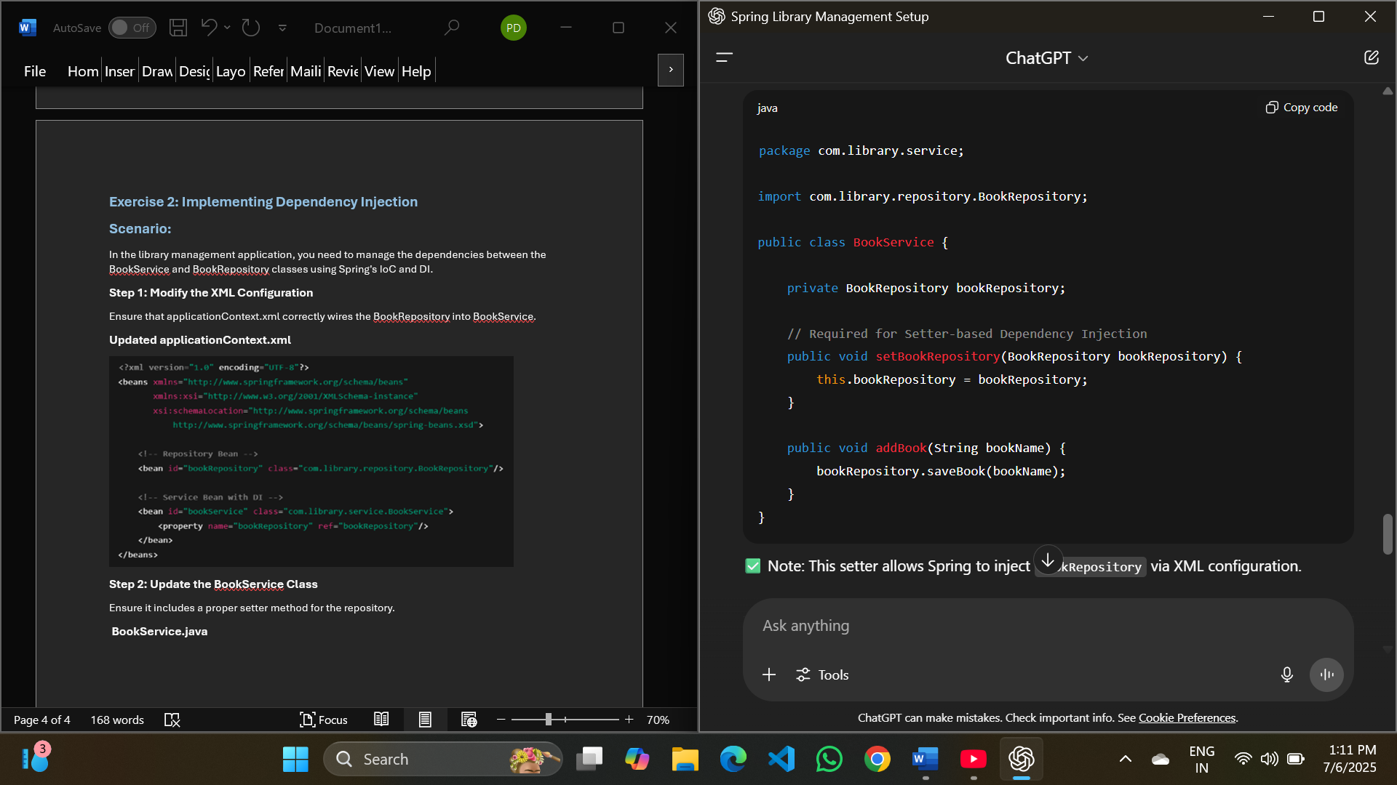
Note: This setter allows Spring to inject BookRepository via XML configuration.
Step 3: Test the Configuration
Create or reuse the main class to load the Spring context and invoke the service.
LibraryManagementApplication.java
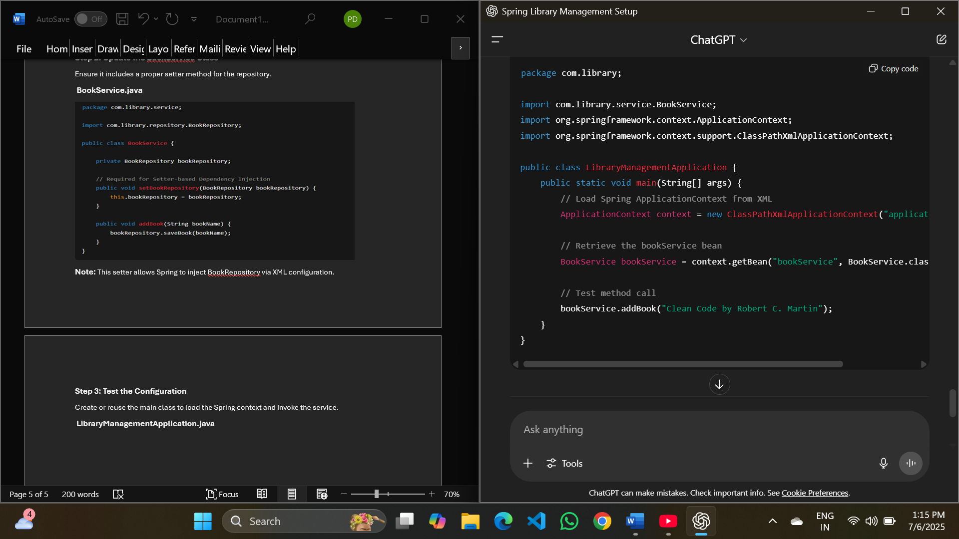

Expected Output:
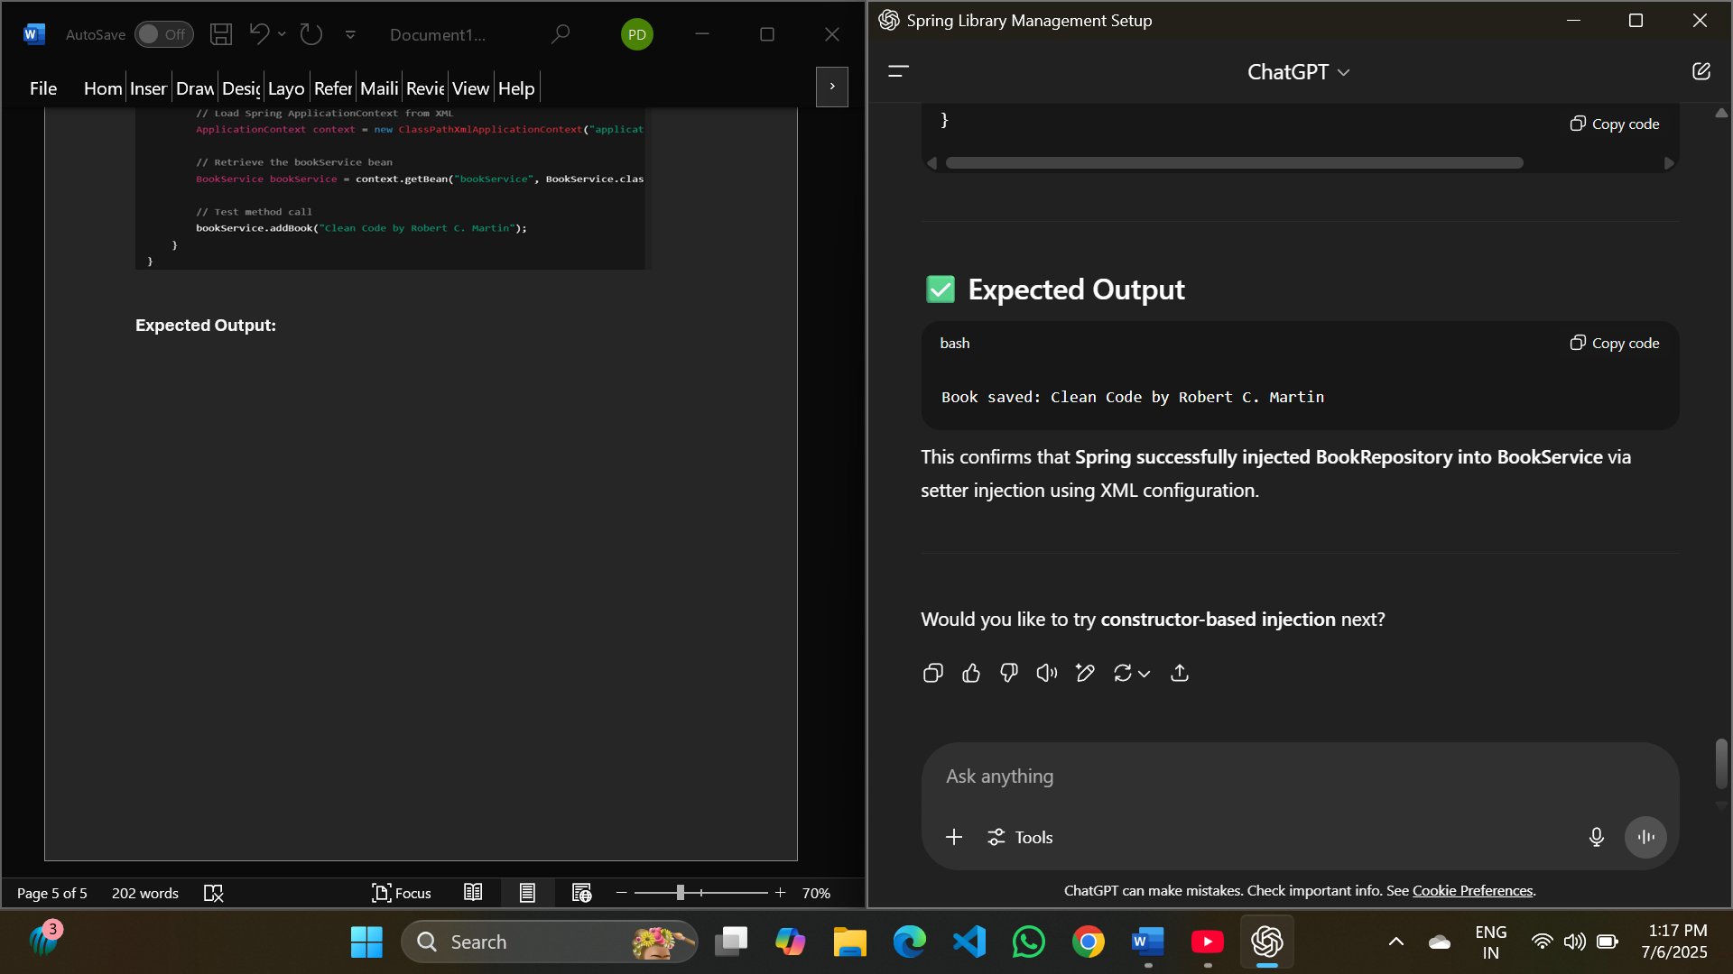
This confirms that Spring successfully injected BookRepository into BookService via setter injection using XML configuration.

Exercise 4: Creating and Configuring a Maven Project
Scenario:
You need to set up a new Maven project for the library management application and add Spring dependencies.
Step 1: Create a New Maven Project
Use your IDE (IntelliJ, Eclipse, or VS Code) or terminal to create a Maven project:
- Project Name: LibraryManagement
- Group ID: com.library
- Artifact ID: LibraryManagement
- Packaging: jar (or war if planning for a web app later)
Step 2: Add Spring Dependencies in pom.xml
Complete pom.xml file:
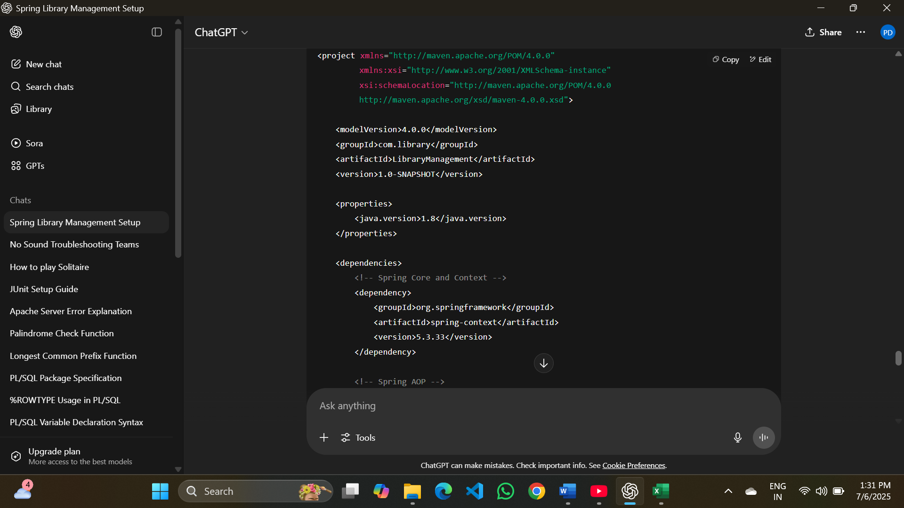
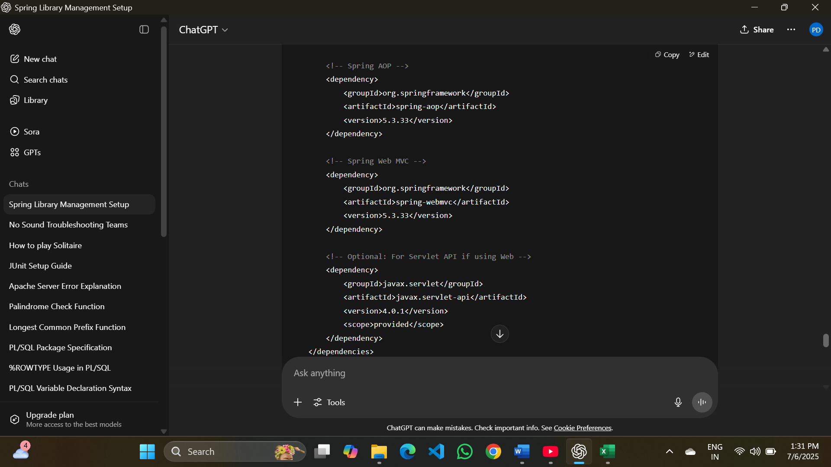
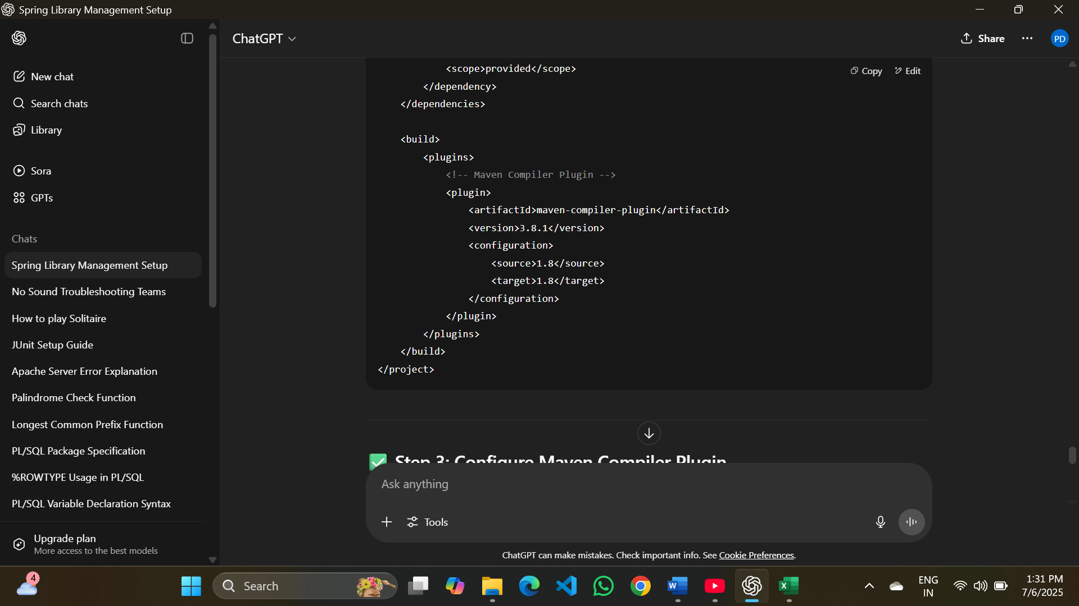
Step 3: Configure Maven Compiler Plugin
Already handled in the <build> section above:
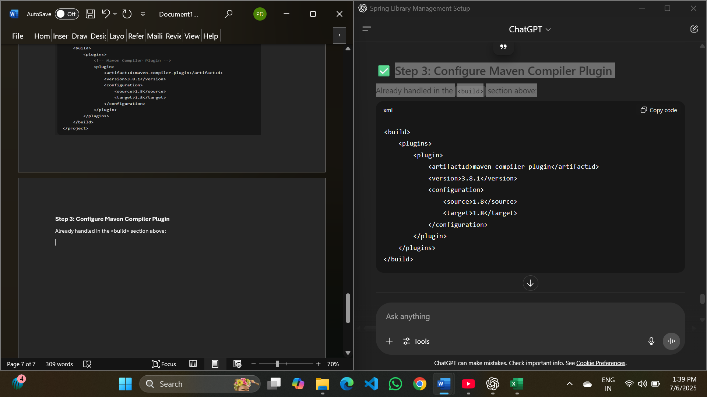

After setup:
To build the project, use your IDE’s Maven tool or run:
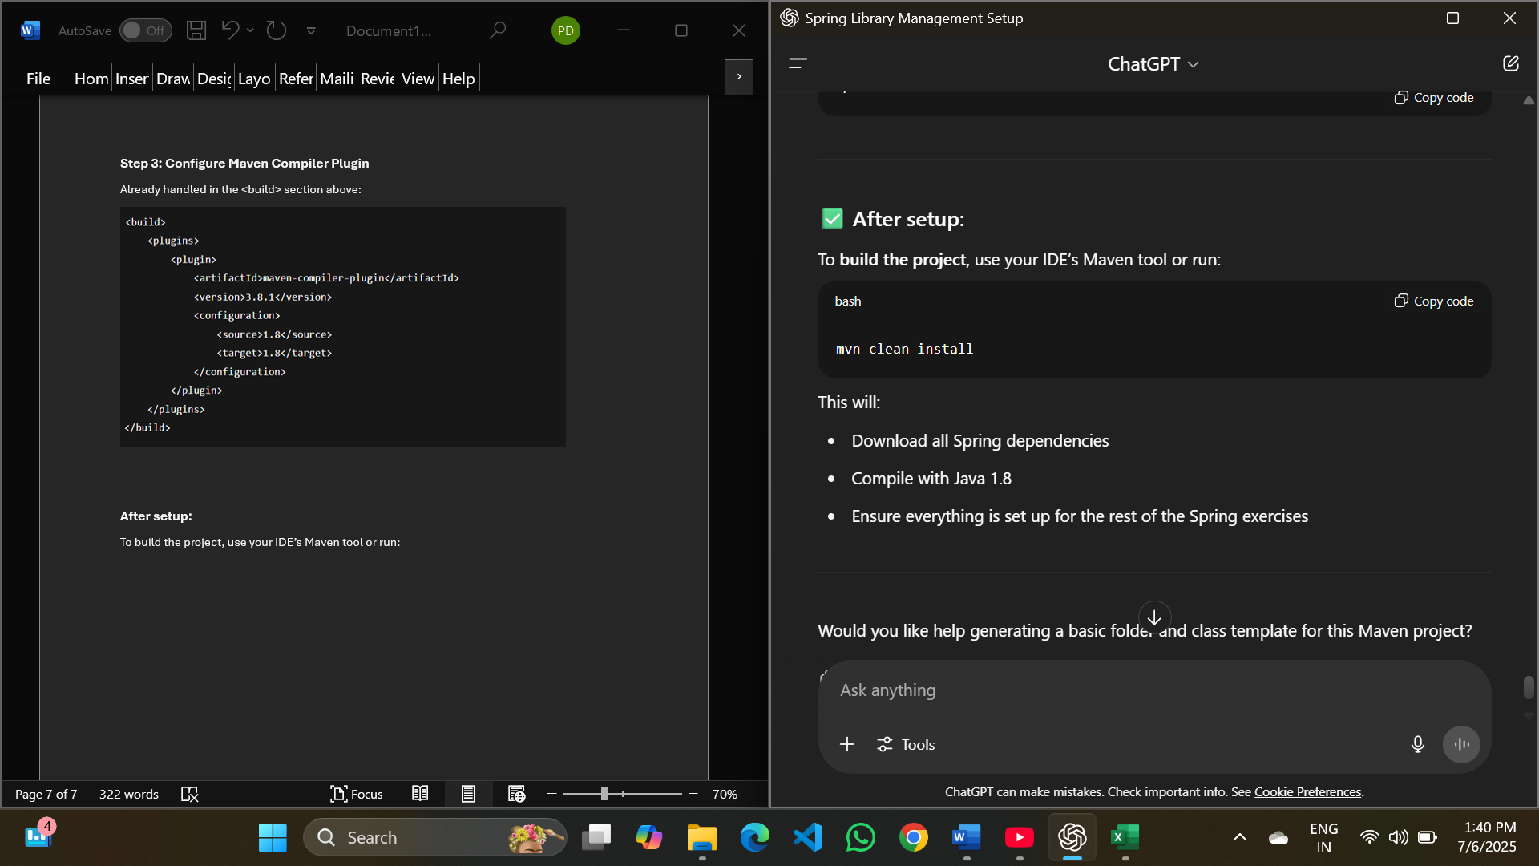

This will:
- Download all Spring dependencies
- Compile with Java 1.8
- Ensure everything is set up for the rest of the Spring exercises

Spring Data JPA with Spring Boot, Hibernate

Spring Data JPA - Quick Example
Screenshots to the steps performed
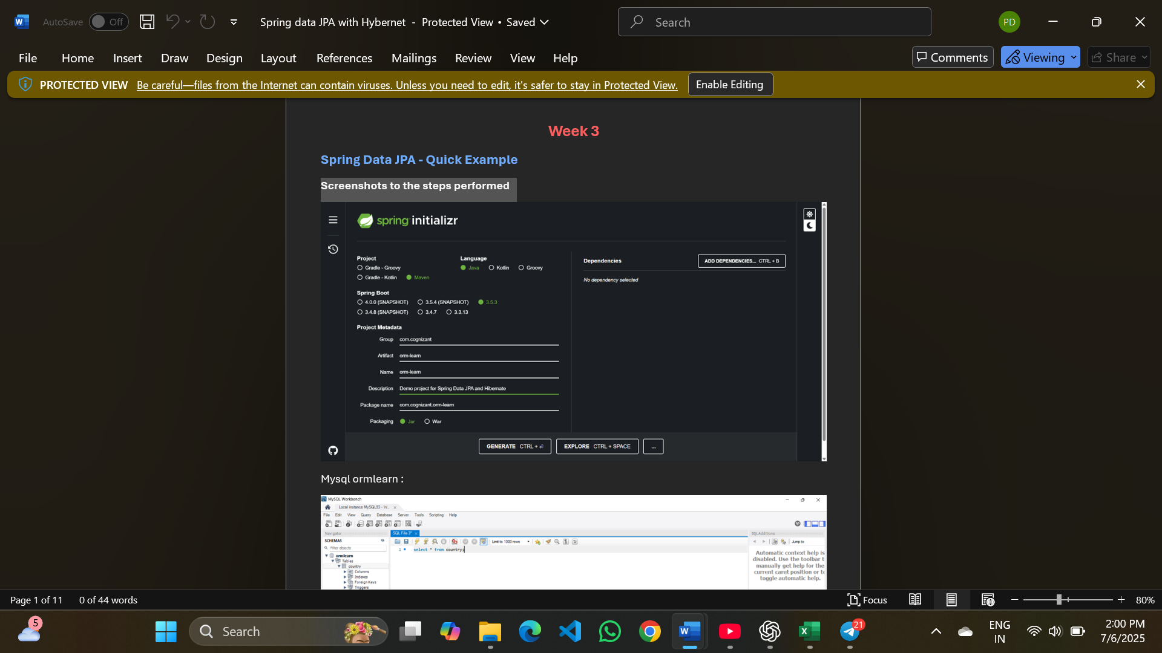
Mysql ormlearn :
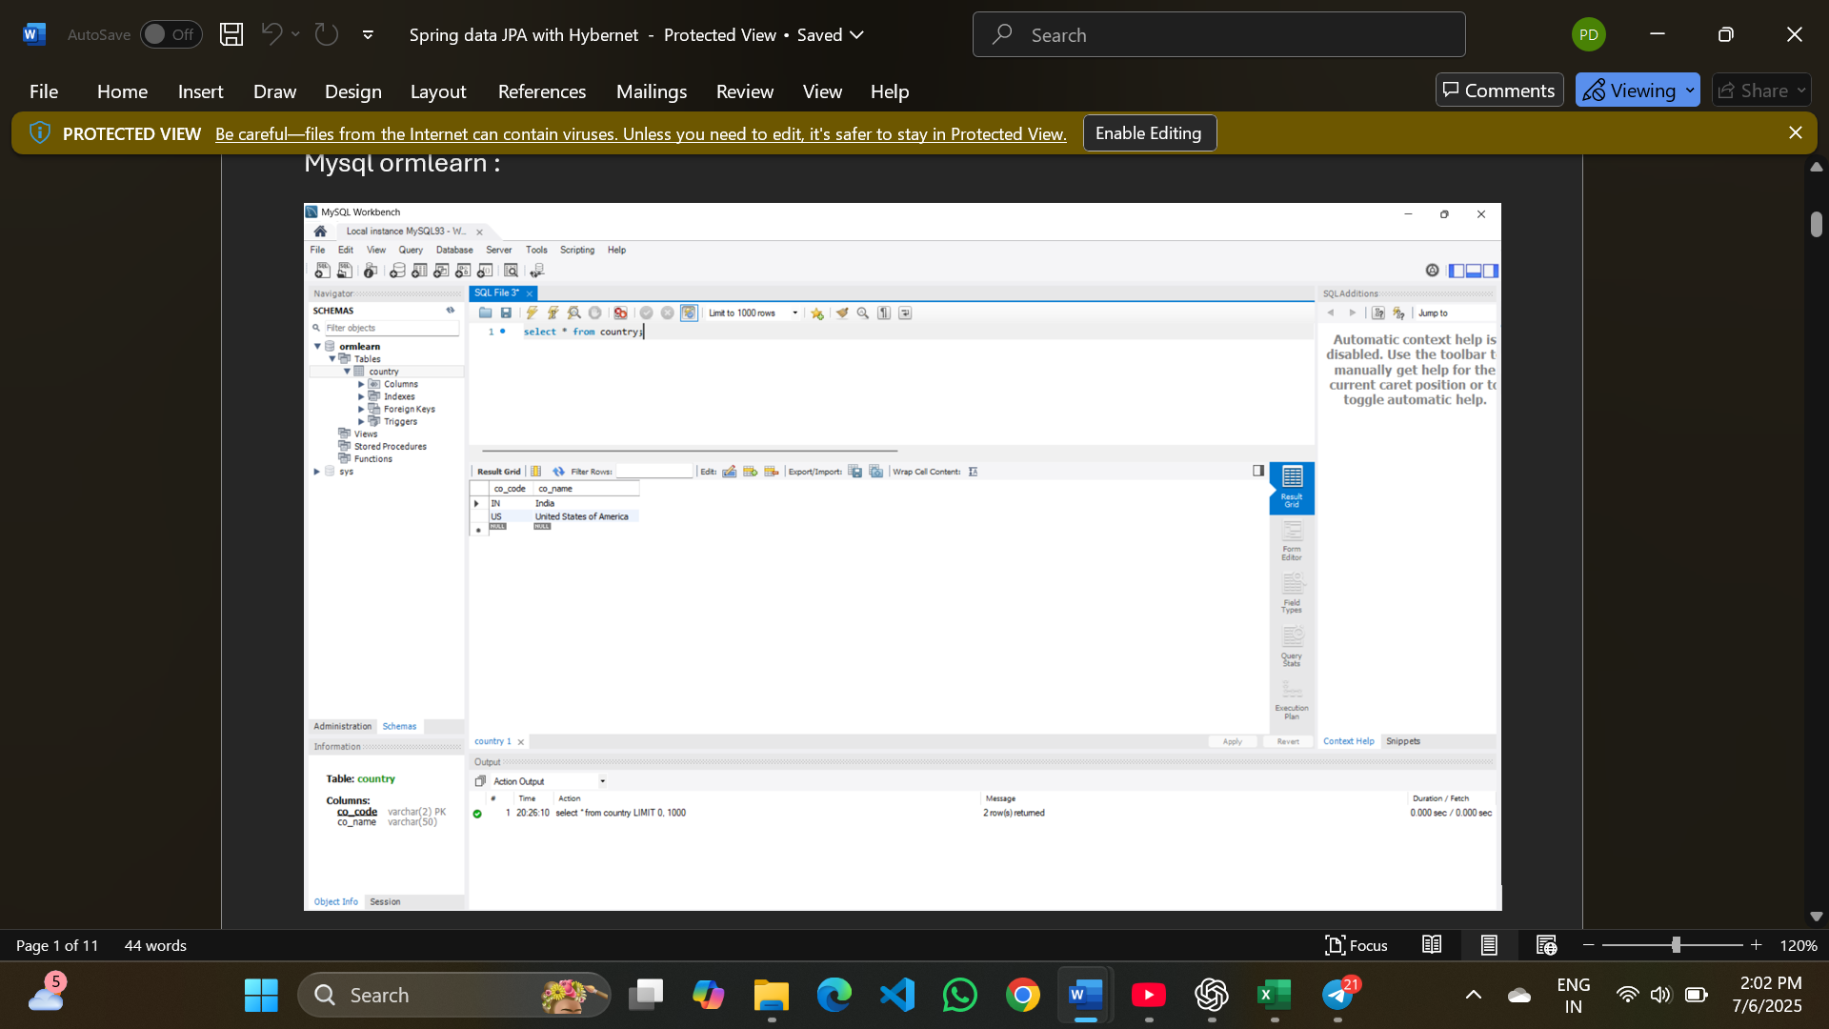
Project orm-learn:
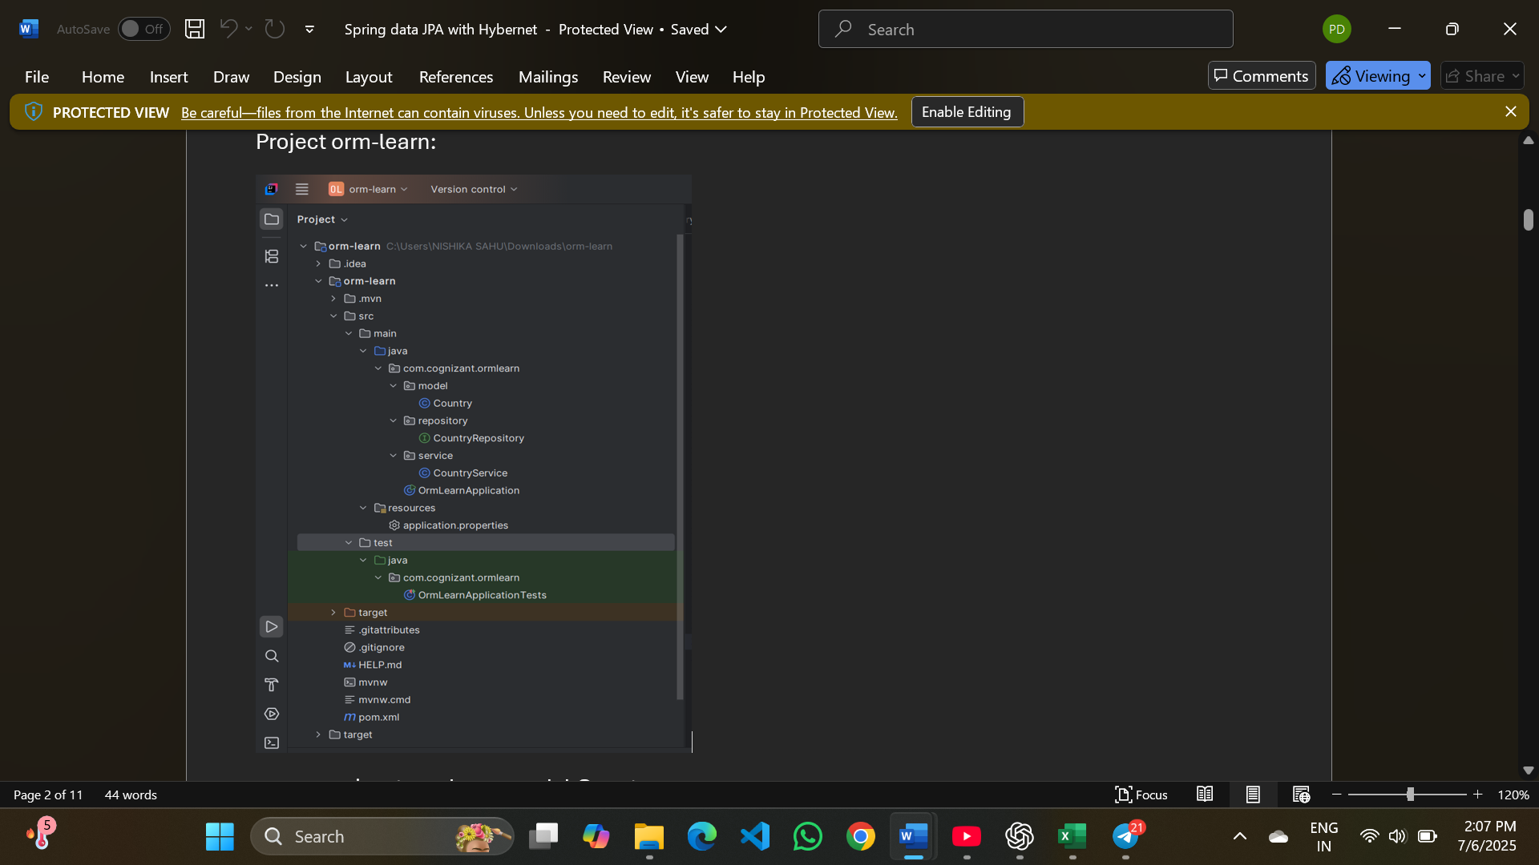
com.cognizant.ormlearn.model.Country :
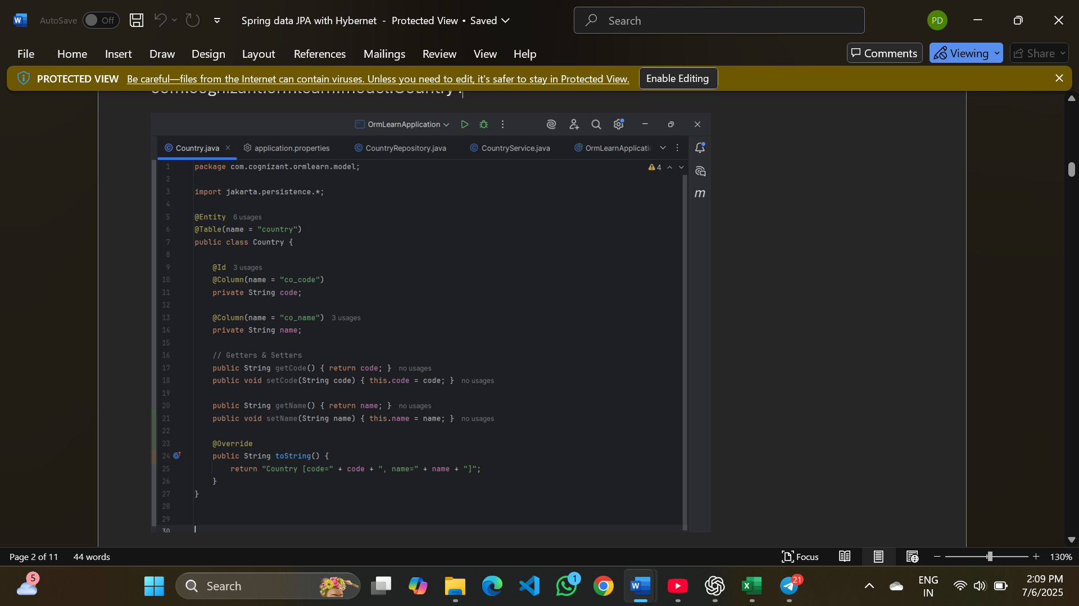
com.cognizant.ormlearn.repository.CountryRepository :
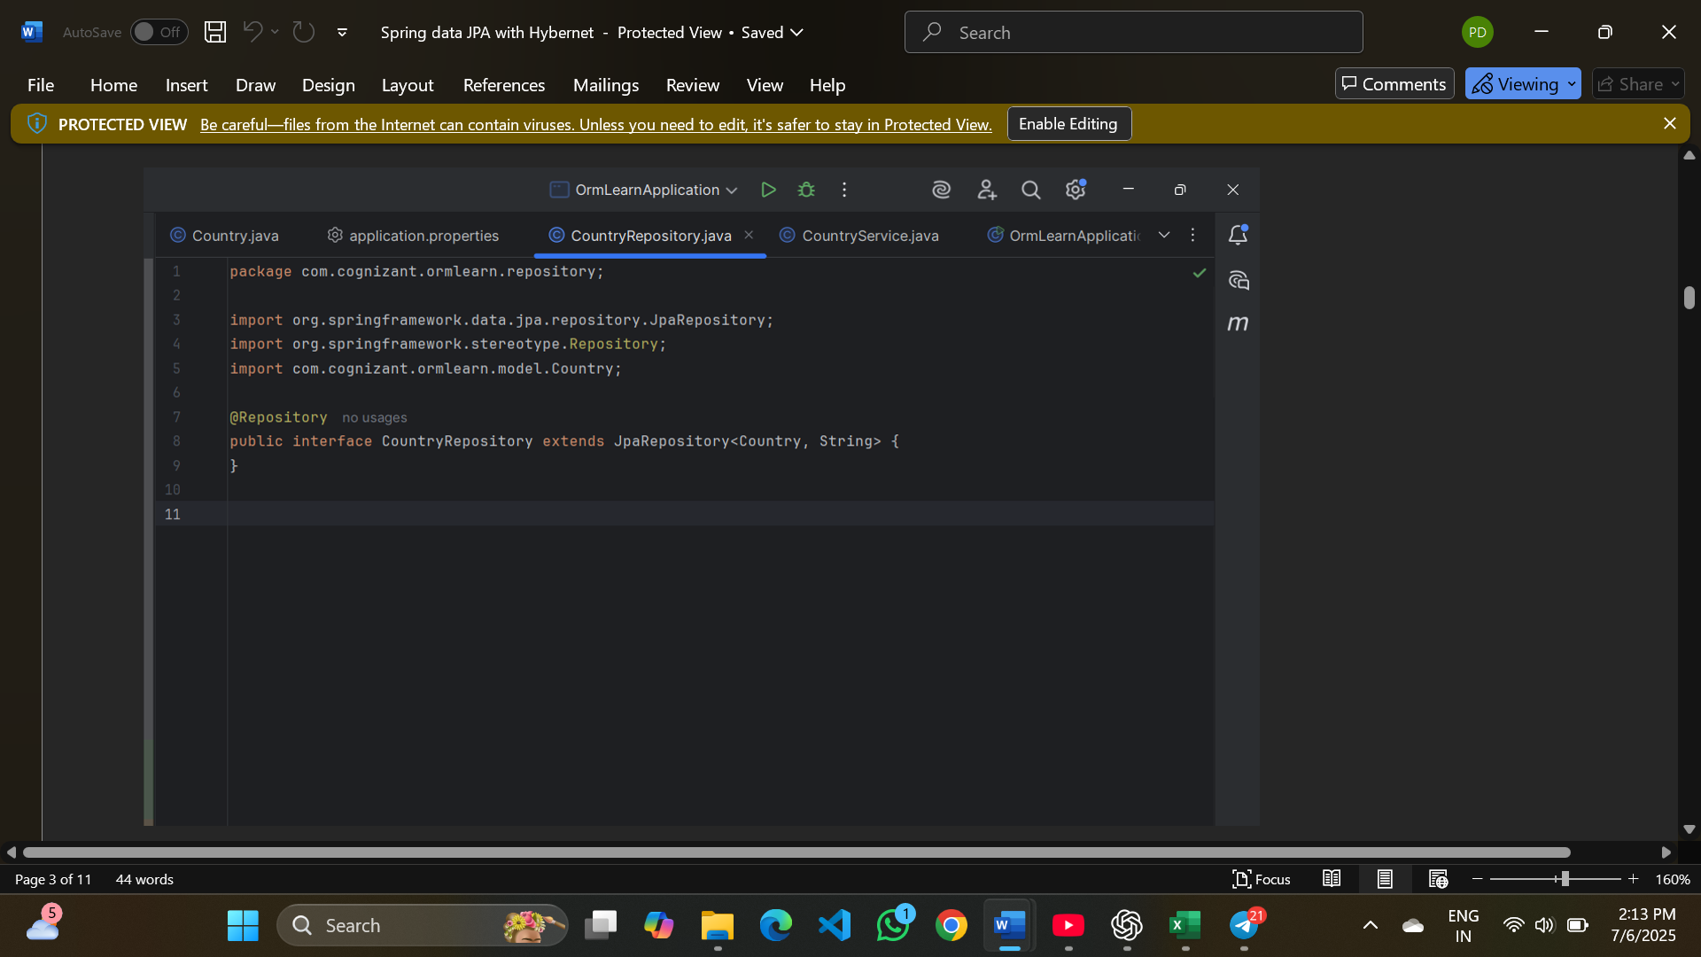
com.cognizant.ormlearn.service.CountryService :
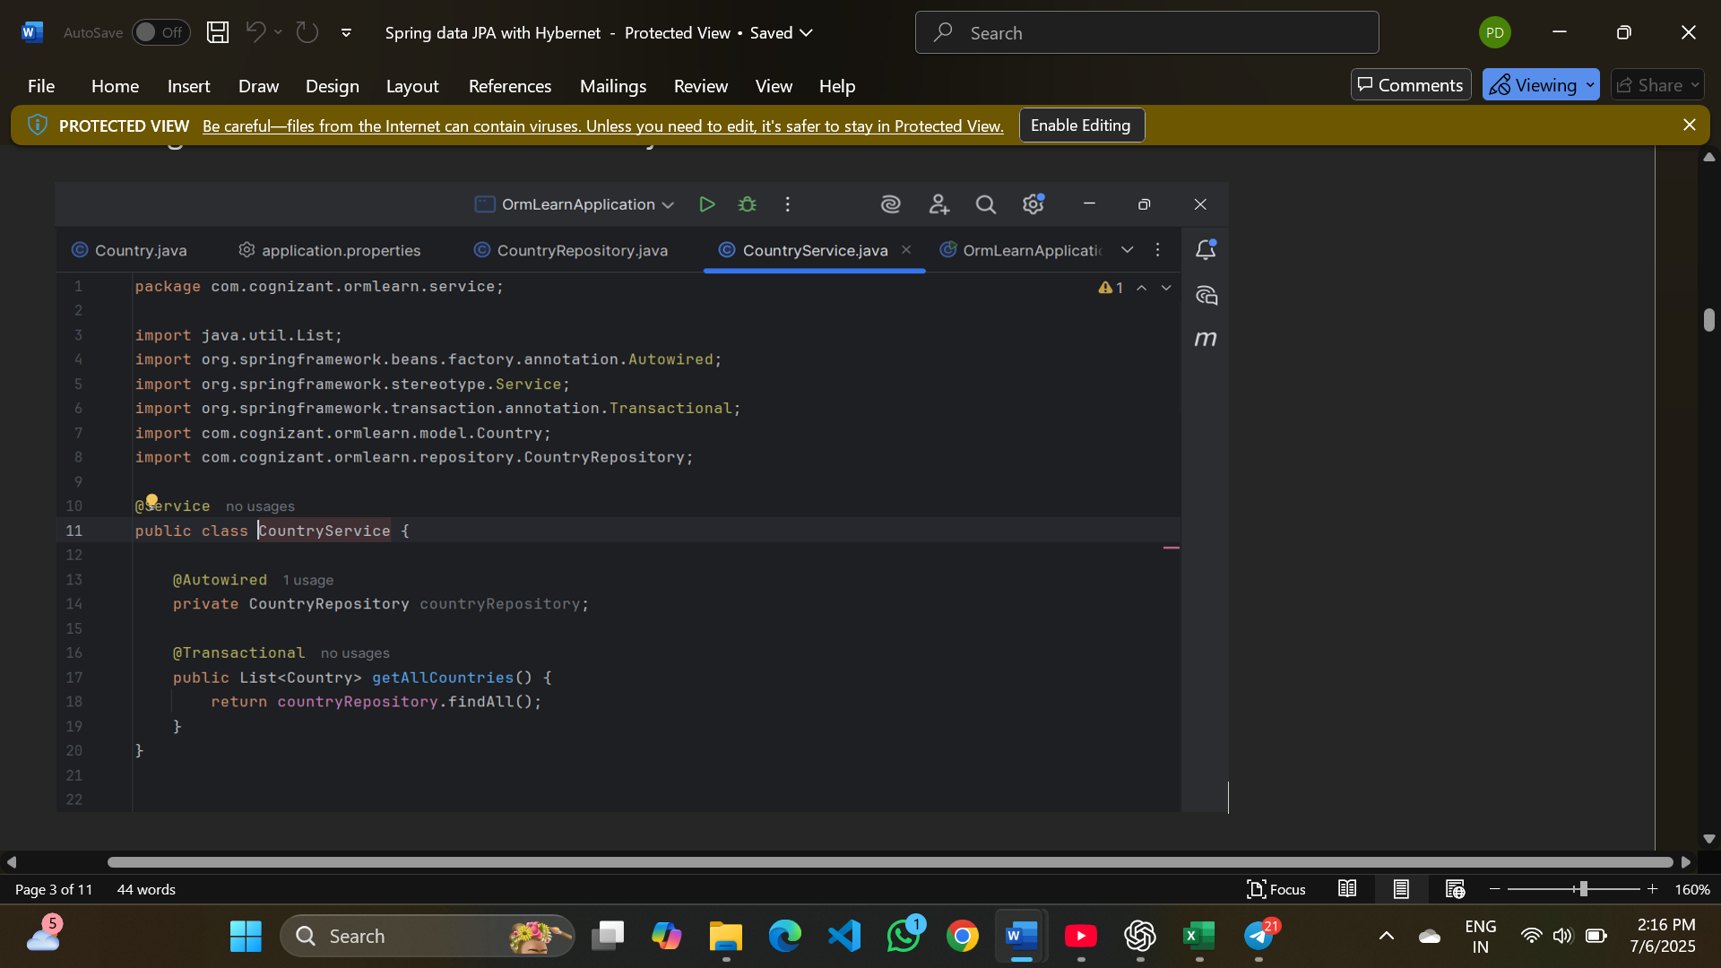
Com.cognizant.ormlearn.OrmLearnApplication.java:
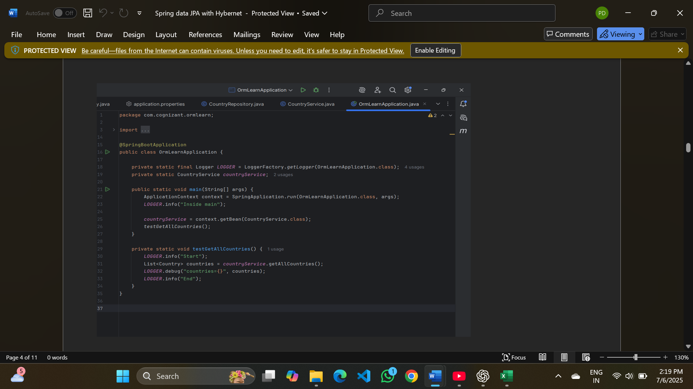

Application.properties :
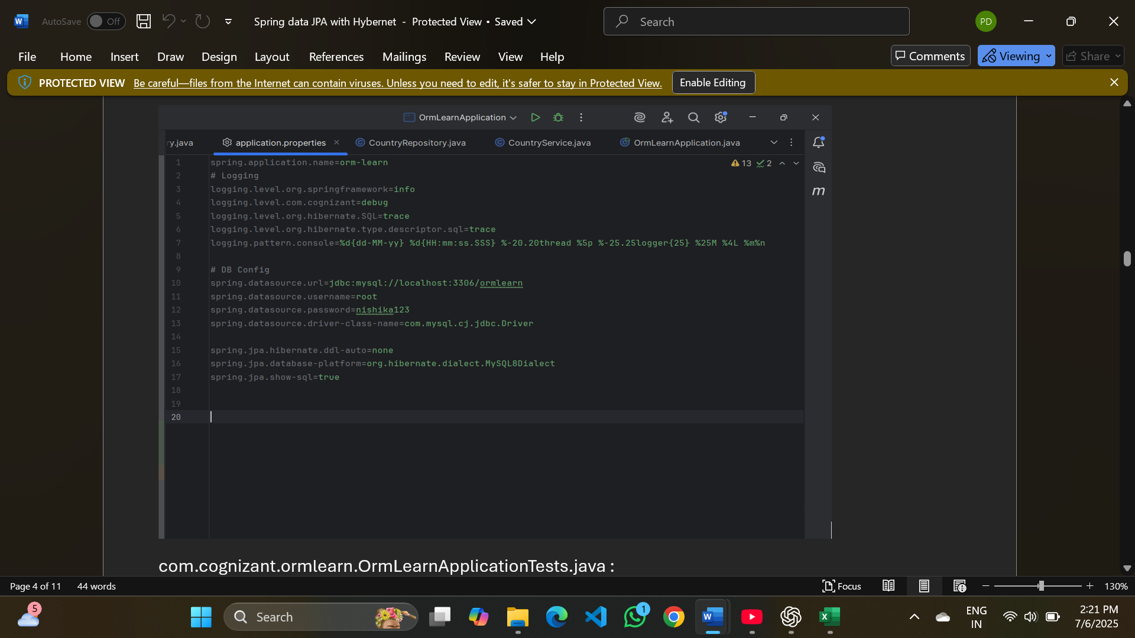
com.cognizant.ormlearn.OrmLearnApplicationTests.java :
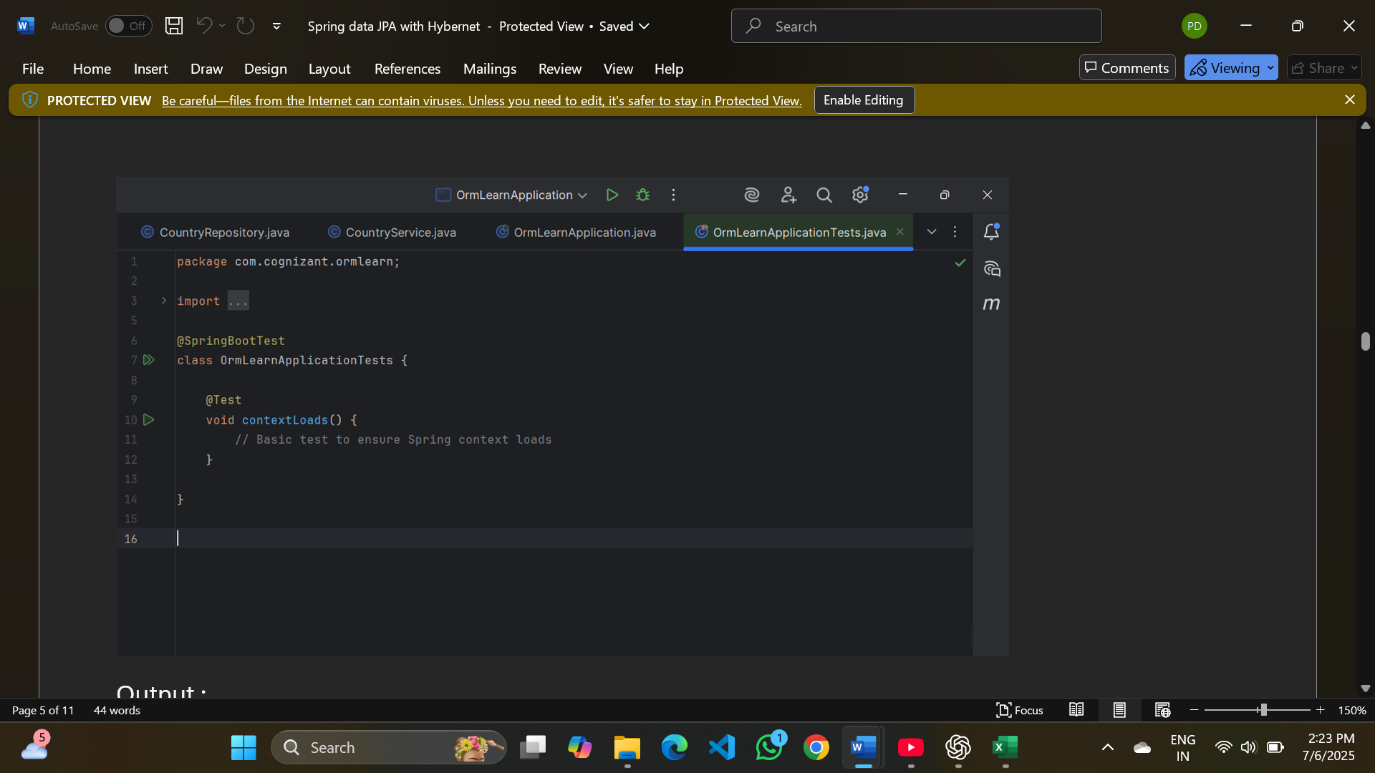
Output :

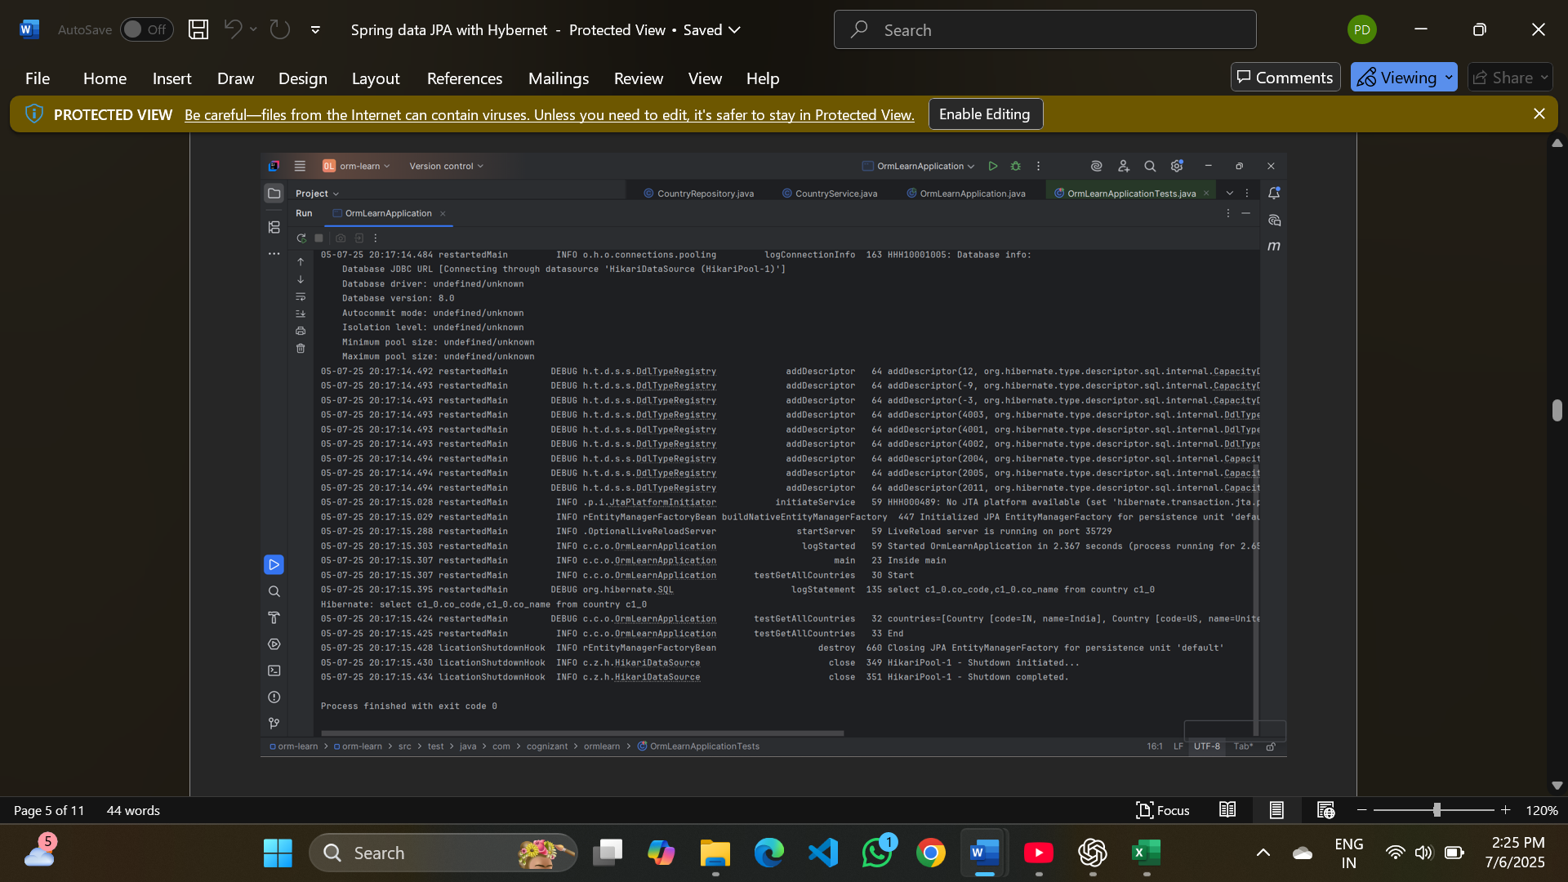

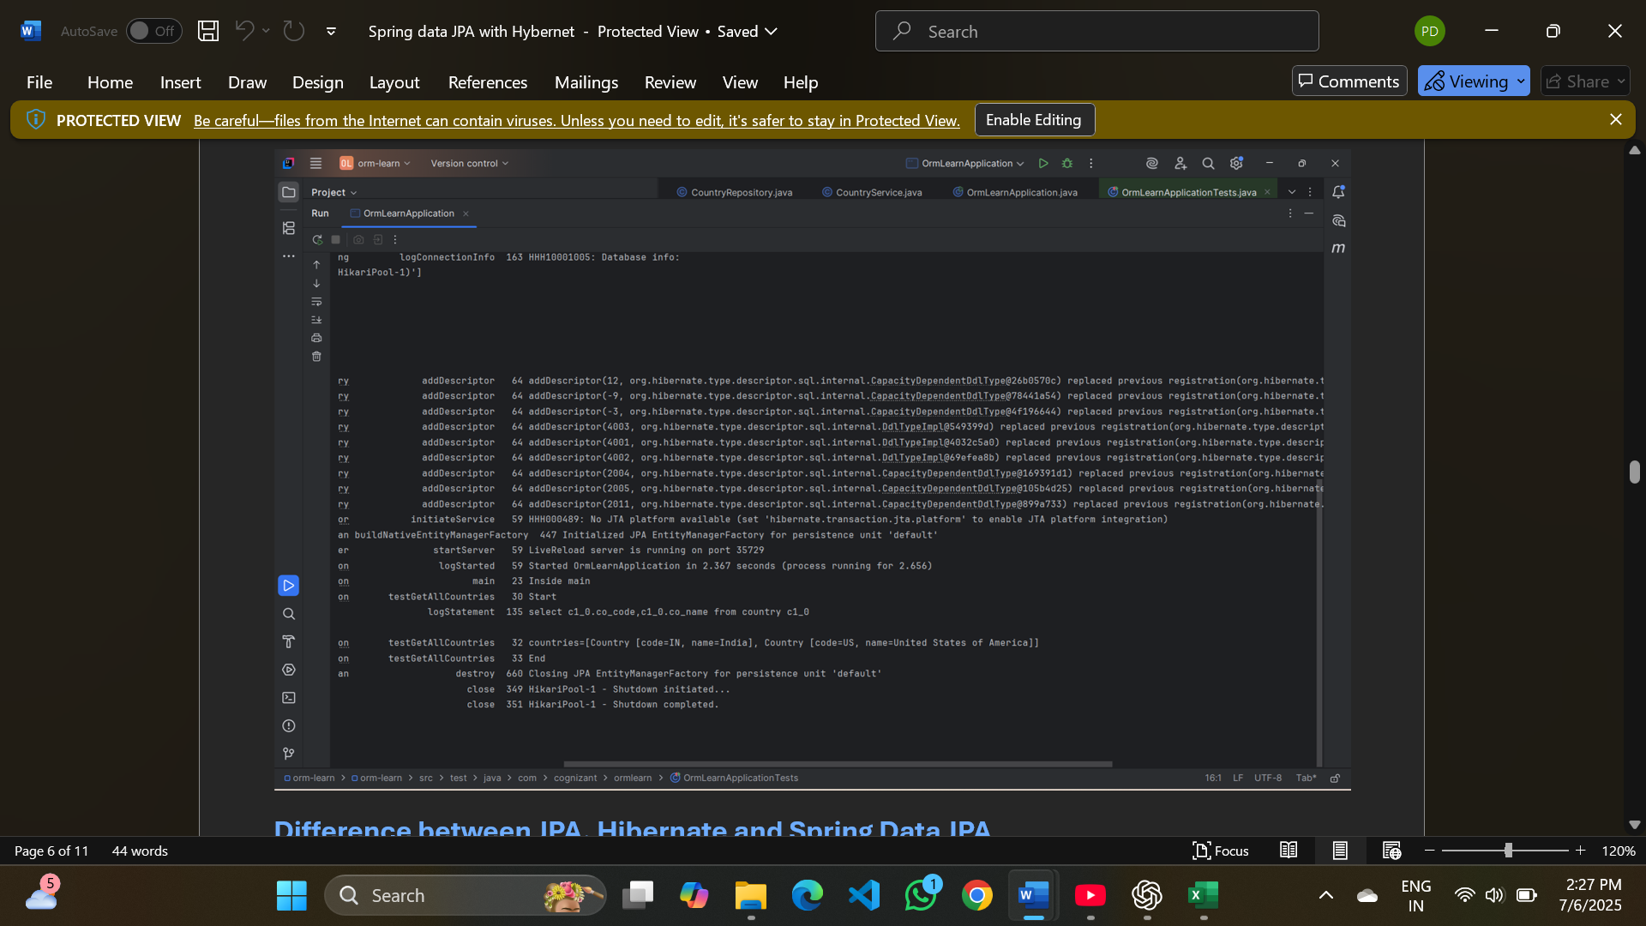

Difference between JPA, Hibernate and Spring Data JPA
Hibernate:
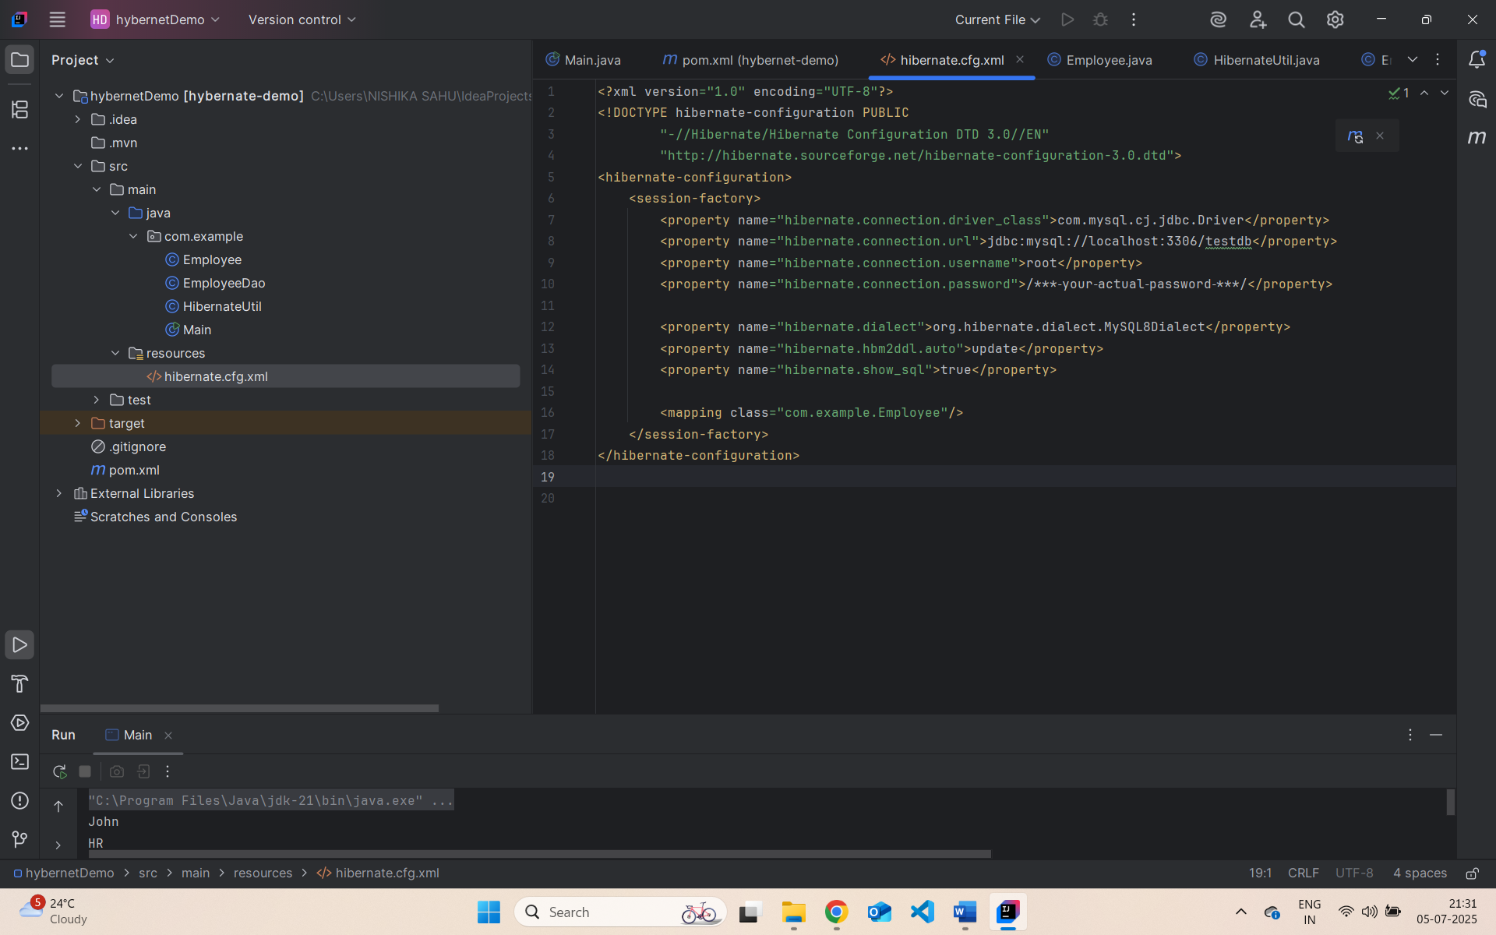

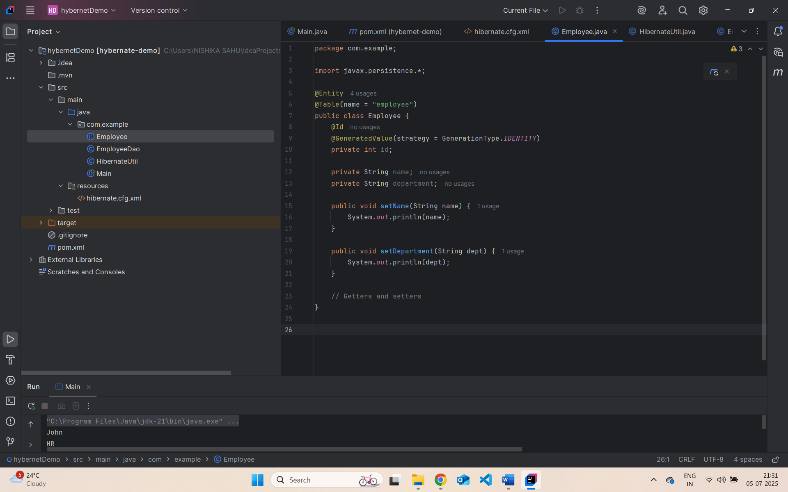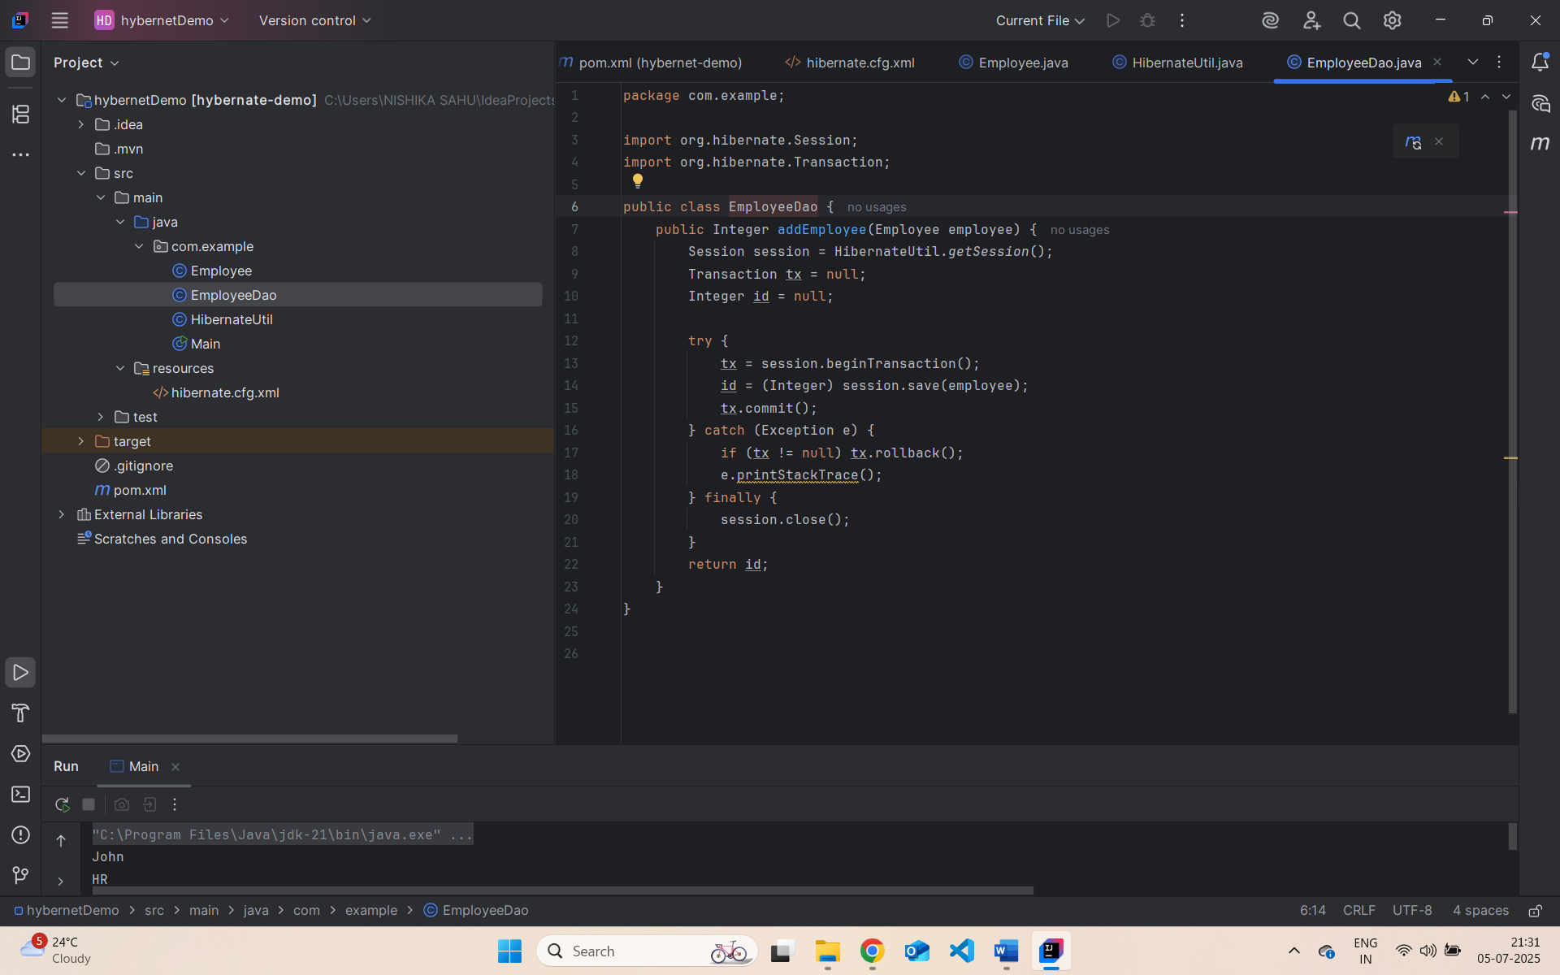

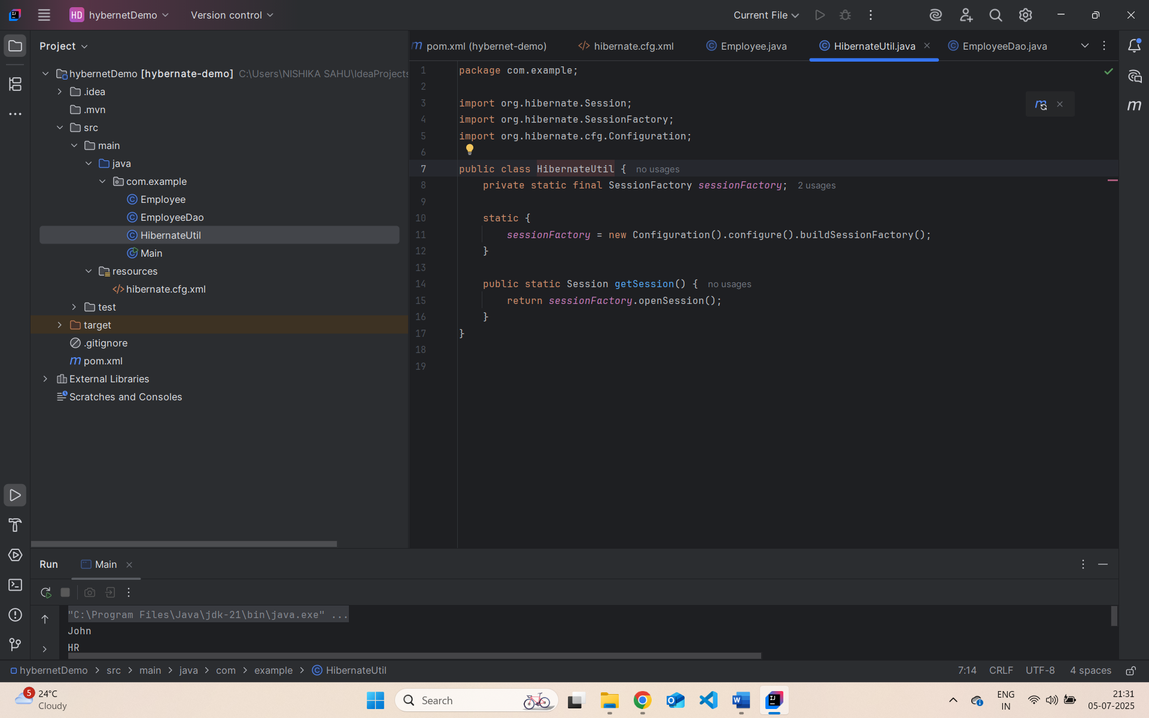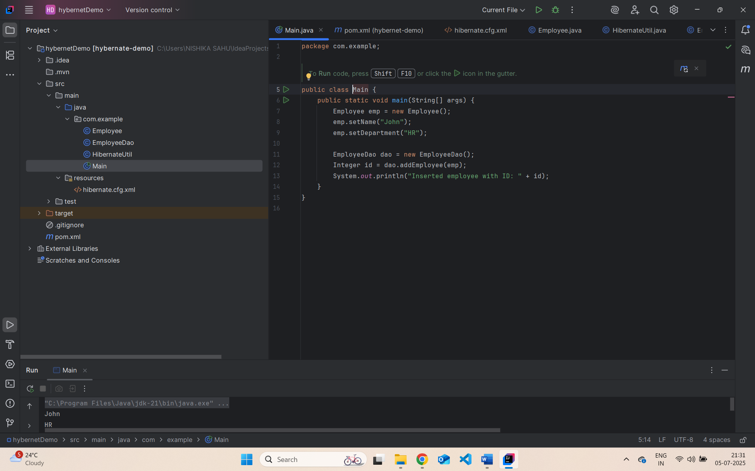

Spring Data JPA:
